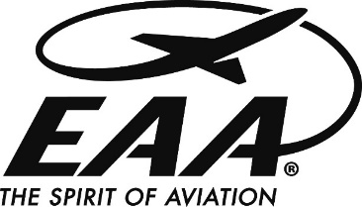
For more information contact:

____________________ ____________
Chapter Representative Title

_________________________________
Address

____________________ ____________
Phone Fax

_________________________________
Email

FOR IMMEDIATE RELEASE

LOCAL EAA ‘FLYING START’ PROGRAM PART OF NATIONAL LEARN TO FLY WEEK

(city)____________, (state)____ — Those who have ever thought about learning to fly can find out more on (date)____________, as EAA Chapter (number) hosts a “Flying Start” informational program on learning to fly at (LOCATION).

EAA Chapter (NUMBER), a local organization that is part of the national Experimental Aircraft Association, is dedicated to growing participation in aviation by sharing the ways people can get started in this fun and fulfilling recreation.

The program will be held at (time) _______ on (day, date) ___________________, at (location) _____________. (Please add directions if location not well known locally). Anyone with an aviation interest is invited to attend.

EAA’s Flying Start program introduces interested individuals to the endless opportunities and fun that result in earning a pilot’s certificate. The event will cover the steps and requirements in learning to fly, provide tips on how to make it economical, and will culminate in a free introductory flight.

EAA Chapter (number)’s Flying Start Event is being held in conjunction with EAA Learn to Fly Week; a national campaign to help aspiring pilots take flight. Leading up to the Flying Start event, individuals interested in learning to fly can participate in variety of free interactive webinars hosted live. These webinars will run May 15 through May 19, and cover topics ranging from getting started in flight training, how to save time and money, and other flight training tips. Webinars are free to attend, but pre-registration is required at www.EAA.org/LTFWeek.

EAA has approximately 900 chapters around the world, which provide activities for local aviation enthusiasts with a mission of growing participation in aviation by sharing “The Spirit of Aviation.” Chapter activities range from monthly meetings to airport open houses, fly-ins, educational programs, and pancake breakfasts that share aviation with the community and build a stronger bond between local aviation and the public.

EAA chapters are the backbone of the international EAA organization, which has more than 250,000 members. The local organizations include general EAA chapters as well as specialized chapters for Vintage aircraft, Warbird, Ultralight and Aerobatic flight enthusiasts.

For more information about this Flying Start session, contact (name) ___________________ at (number)_______________ or (secondary contact #)_________________.

