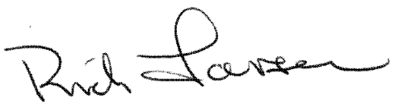
2020

CHAPTER SERVICE AWARD
PRESENTED TO:
First Last
Position or Award
EAA Chapter Number

For dedicated service within your Chapter, this award is presented in
recognition of your service and assistance to foster the growth of
recreational aviation through Chapter activities.

Rick Larsen
EAA Vice President, Communities and Member Programs

Experimental Aircraft Association

