OSH-2016
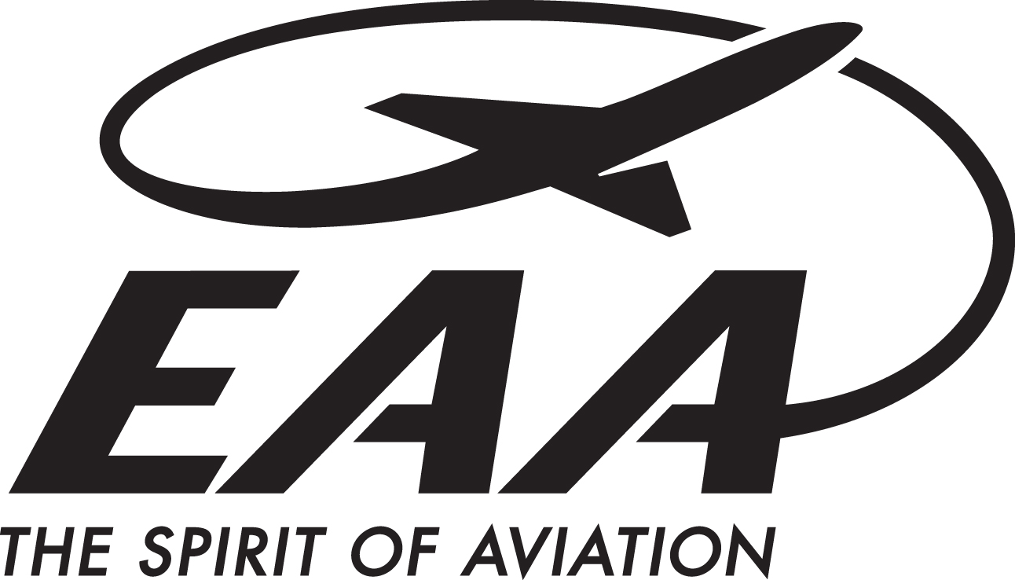
For more information contact:
Nicole Rayos, Marketing Communications
920-426-5907
nrayos@eaa.org

FOR IMMEDIATE RELEASE

EAA’s B-17 Aluminum Overcast Takes to the Skies
for 2016 Tour
‘Mission’ flights, ground tours in historic World War II bomber available to the public
EAA AVIATION CENTER, OSHKOSH, Wisconsin — (Date. x, 2016) – The Experimental Aircraft Association’s restored B-17 World War II bomber Aluminum Overcast returned to the sky on April 28 in Davenport, Iowa, the first of more than 40 stops during the 2016 Join the Flight tour.
The first portion of EAA’s tour schedule includes 15 stops in the United States between April 28 and July 24. The yearlong tour will continue into the summer, with the airplane back “home” for EAA’s annual AirVenture celebration on July 25–31 in Oshkosh, Wisconsin. After AirVenture, the aircraft will continue it’s tour throughout stops along the midwest and the east coast.
Since EAA began tours of the aircraft in 1994, tens of thousands of people have experienced this unique airplane through its flights and ground tours. Known as the Flying Fortress, the B-17 bomber is considered one of the greatest military airplanes ever built and one of the best-known aircraft types of the World War II era.
“For 20 years, EAA’s national B-17 tour has been America’s most popular way to learn about this unique aircraft in an up-close way,” said Jack Pelton, EAA’s CEO. “EAA is dedicated to preserving The Spirit of Aviation through these B-17 tours. It is more than the flight of a historic aircraft – it is an emotional connection to the men and women who were part of the greatest generation and the sacrifices they made to benefit us in subsequent generations.”
At each stop, flight “missions” allow people to experience this spectacular aircraft from the air. Riders are allowed to roam the cabin mid-air if they choose to do so.
For more information, including rates for flights and ground tours, visit www.B17.org or contact EAA’s Air Tours Manager, Kristin Busse, at 920-426-4843. Special pre-book rates on flights are available.
EAA’s Aluminum Overcast was built in 1945, but was delivered to the Army Air Corps too late to see active service in World War II. The B-17 was donated to the EAA Aviation Foundation in 1981 with the provision the aircraft be maintained in airworthy condition. After being displayed at the EAA AirVenture Museum in Oshkosh, Wisconsin, for a decade, the airplane made its national tour debut in the spring of 1994. Today, EAA’s Aluminum Overcast is proudly supported by Phillips 66® Aviation and Tempest Aerospace, helping keep this beautiful aircraft in the air.
About EAA
EAA embodies the spirit of aviation through the world’s most engaged community of aviation enthusiasts. EAA’s 190,000 members and 1,000 local chapters enjoy the fun and camaraderie of sharing their passion for flying, building and restoring recreational aircraft. For more information on EAA and its programs, call 800-JOIN-EAA (800-564-6322) or go to www.EAA.org. For continual news updates, connect with www.Twitter.com/EAA.
EDITOR’S NOTE: To book a media flight on EAA’s B17 Aluminum Overcast, please contact Emily Mustain at emustain@eaa.org.

