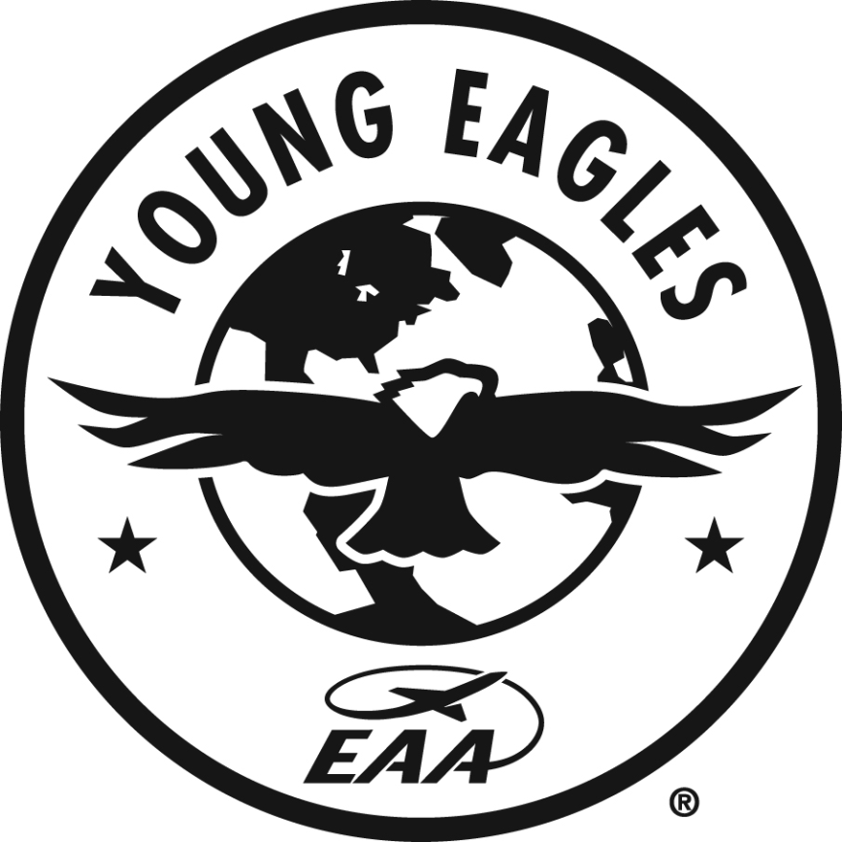

2015
Young Eagles Awards

Nomination

Form

Deadline
2015 EAA

June 15, 2015

2015 Annual EAA Young Eagles
Award Nomination Form

The EAA Young Eagles program has become a success thanks to the efforts of EAA-member volunteers around the world. This is your opportunity to nominate someone who has made significant contributions to the overall success of the Young Eagles program. EAA chapters and individual EAA members are invited to nominate outstanding Young Eagle volunteers for the following awards:

* Chapter Coordinator
* Ground Support Volunteer
* Young Eagles Horizon Award (recognizing efforts to go beyond the basic Young Eagles flight)

Nomination materials should include this form, detailed descriptions of the accomplishments of the nominee, any relevant background information and letters of recommendation from fellow EAA members. Nominations for 2015 are open through June 15, 2015. The 2015 awards will be selected in June and are presented at a special ceremony held at EAA AirVenture Oshkosh on Wednesday evening, July 22, 2015.

2015 Annual EAA Young Eagles Award

Nominating Chapter Information

Division: EAA IAC WAR VIN U/L (Please circle one.) Chapter #:

Young Eagle Award Nominee Contact Information

First Name:
Last Name:
EAA #:

Mailing Address:

City:

State:

Zip:

Phone #:

E-Mail Address:

President’s Contact Information

First Name:
Last Name:
EAA #:

Mailing Address:

City:

State:

Zip:

Phone #:

E-Mail Address:

Award Category Submission (please “X” category)

Chapter Coordinator

Ground Support Volunteer

Young Eagles Horizon

Return Nomination Forms and Materials To:

Young Eagles Office, PO Box 2683, Oshkosh WI 54903
Fax #: 920-426-6579

Deadline for Nomination is June 15, 2015

2015 Annual EAA Young Eagles Award Nomination
Please type or print all information:

Description of Nominee’s Accomplishments (Feel free to add additional information):

NOTE: All entries must be received in the EAA Chapter Office no later than June 15, 2015 to be eligible. Mail Entries To: EAA Young Eagles Office, PO Box 2683, Oshkosh WI 54904
FAX: 920-426-6579

